**Steam-Library-Manager - Design Document**

Quick and dirty design doc – might get improved late

**Functional Description**

An application that is portable that can be opened to view a user’s steam library mapped across multiple file locations as a searchable/ filterable / sortable list. This allows a user to keep most of their games on a NAS or other external drive that may not be mapped in steam as a library.

This list of will show metadata about the games such as:

* File location (including drive)
* size on disk
* last updated (date)
* etc.

From the list the user will be able to move games (either one at a time or in bulk) from one drive to another as well as to move a game to removable media.

The app should be able to display the remaining disk space as well as how large the entire library is on that disk. (Pretty graphs plots)

The app will need some settings and permanence where the user can configure the library locations, whether to use windows explorer copy or robocopy, etc

Ideally the app will be able to tell if an app is up to date and if a game is installed in multiple locations which one is more up to date and sync any updated files to the older version.

**UI**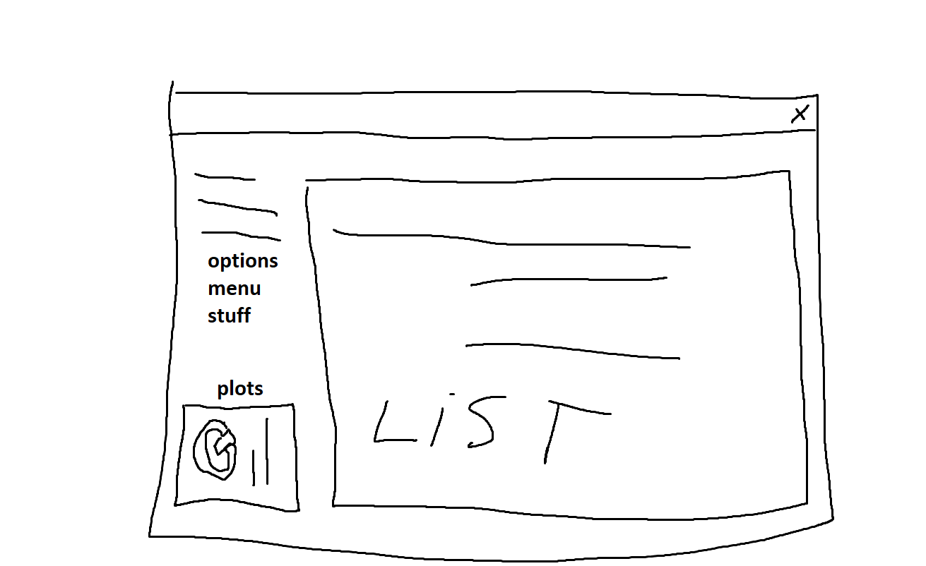

**Milestones – not in order**

* App can parse app manifests into memory
* App can move a game from one location to another
* UI can display list of games with metadata
* UI can move a game from one location to another
* UI can display system disk metadata
* App can move a game to removable media
* App can check if a game is up to date

Stretch Milestones

* App can move workshop files
* App can update other file locations with missing updates
* App can utilise steam API for further data

**Timeline**

None hahahahaha